**Sprint 1 Report, Detective Dollar**

Detective Dollar Team. Completion by Monday 10/30/23

**Actions to stop doing:**

* The team should discontinue addressing individual issues early in the meetings and instead start each meeting with a general overview of the three key questions: What have you done? What are you going to do? Any challenges. This will help streamline our meeting process and prioritize the discussion of challenges effectively.

**Actions to start doing:**

* The team should enhance our weekly meetings by creating a more concrete outline of what we aim to discuss and accomplish. A structured agenda will ensure that our meetings are more productive and organized.
* The team should start keeping better track of how long it takes to complete user stories to improve our estimation and planning processes.

**Actions to keep doing:**

* We should continue voicing our concerns and challenges frequently during our meetings to ensure that any potential issues are addressed promptly.
* We should keep updating each other on individual tasks in our Discord channel to promote collaboration and keep everyone informed about ongoing progress.

**Work completed/not completed:**

* Completed User Stories

1. As a user, upon opening the app, I can access a screen that shows today’s spending
2. As a user, I can click a button to go to a screen for inputting an expenditure or income

4. As a user, I will be able to view the title screen with the app name and logo

* Not Completed

1. As a user, I can see that the spending I add updates on today’s spending

**Work completion rate:**

In Sprint 1, the team successfully completed 3 out of 4 user stories. While we were unable to determine the exact number of hours it took each team member to complete the user stories, we did have initial estimates in our Sprint 1 plan for each user story. These estimates were as follows:

* Total for User Story 1: Estimated at 3.75 hours.
* Total for User Story 2: Estimated at 4.25 hours.
* Total for User Story 3: Estimated at 5 hours.
* Total for User Story 4: Estimated at 3.25 hours.

In the future, we plan to do a better job of estimating the time it takes to complete user stories and use this information to enhance our estimation and planning processes for upcoming sprints.

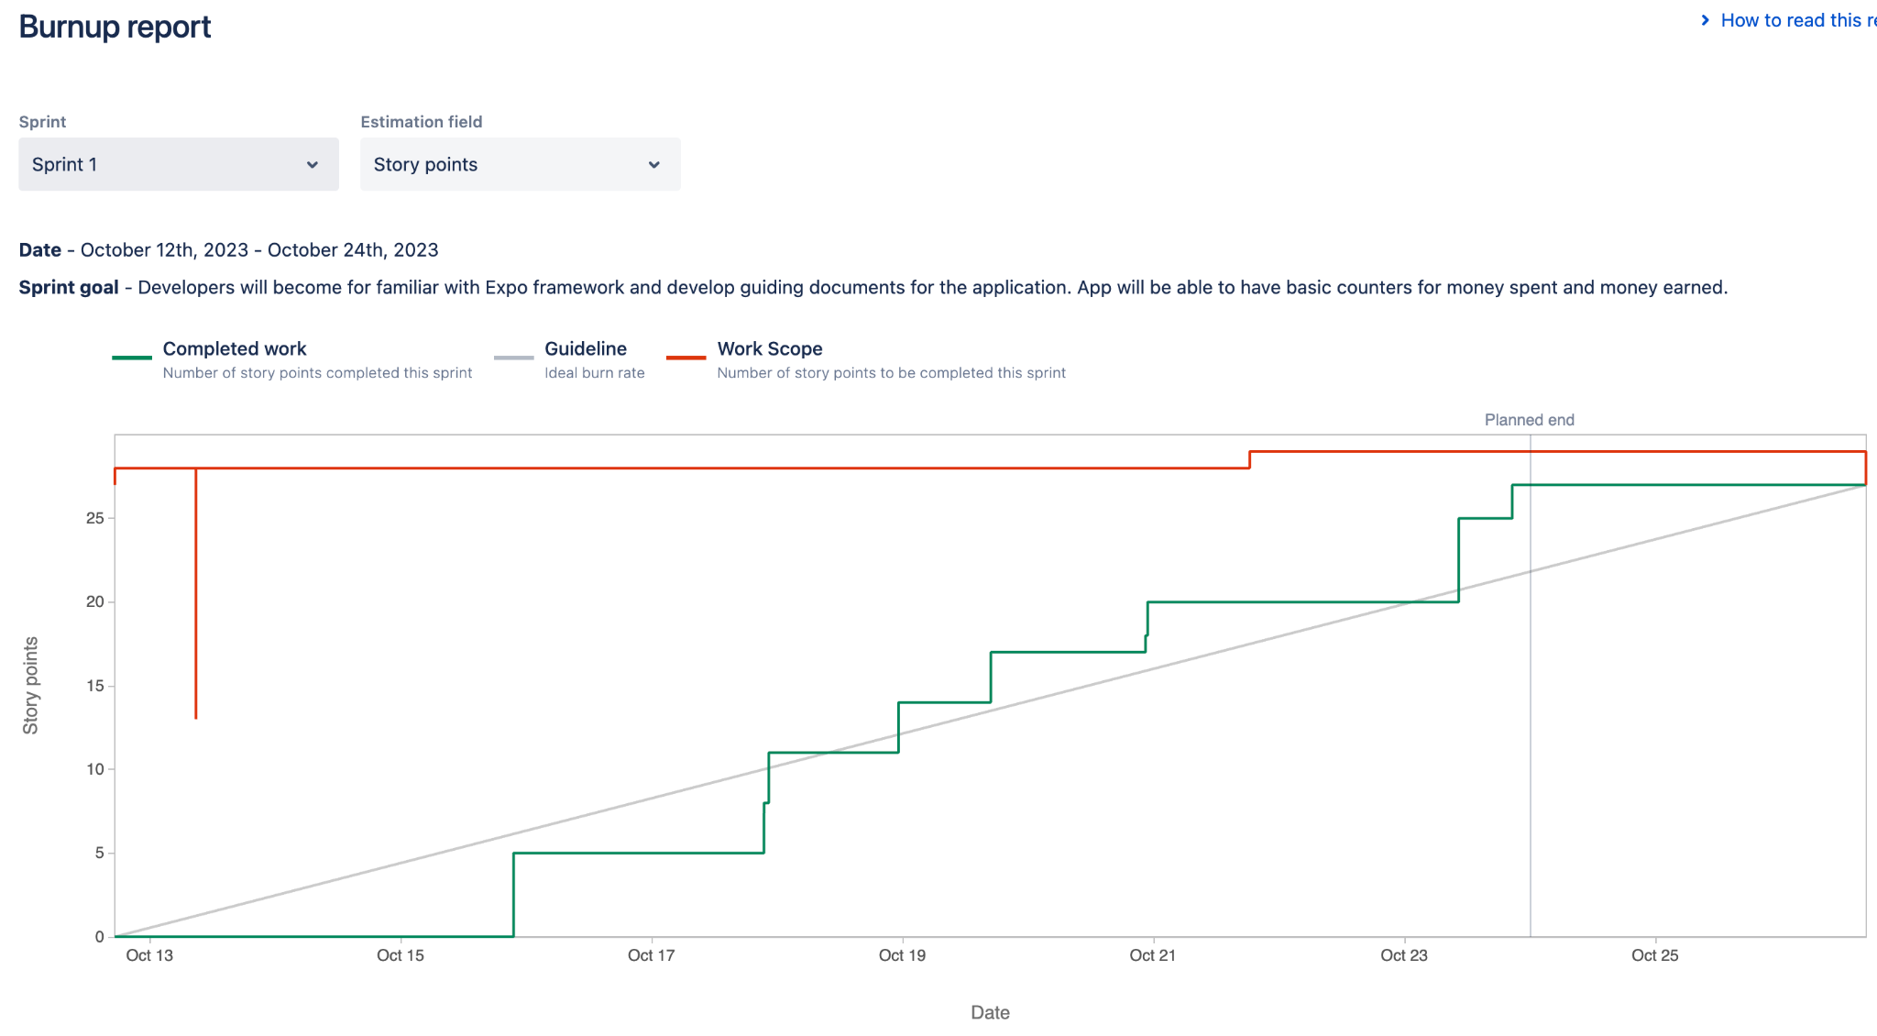

Based on the Burnup chart, we observed that we were behind schedule from the beginning of the sprint until halfway through the sprint. This was primarily due to the team's simultaneous learning curve with Expo and the Scrum process. Most of us were still adapting to Expo and getting acquainted with the Scrum framework. As a result, it wasn't until the second week that we began to grasp the processes and could effectively work on completing the user stories.

Moving forward, the team will become more experienced at handling the development process, as evidenced by our improved performance during the second half of sprint one. We are committed to applying the lessons learned during this sprint to stay on schedule in the future and ensure a more consistent and efficient development process.